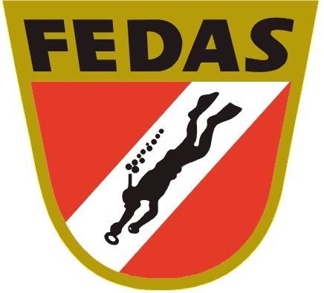 1st EUROPEAN CHAMPIONSHIP UNDERWATER VIDEO

VIDEOGRAPHERS | COUNTRY | POINTS | RANKING
José Carlos Rando | Spain | 27 | 1º
Ronald Faber | Netherlands | 21 | 2º
Katja Kieslich | Germany | 19 | 3º
Jörg Steer | Germany | 15 | 4º
Beeckmans Gery | Belgium | 13 | 5º
Matthias Lebo | Switzerland | - | -
Hector Ripolles | Spain | - | -

